**Airline price prediction analysis**

Introduction

Airline project is all about domestic flights in India tells us how prices are fluctuated at different times for different flights with stops and duration of flight from source city to destination city.

Objective

The aim of the project is to understand airline prices at different times including stops, days left and for different cities in India.

Dataset Description

Airline Data has 11 columns and 300k rows with 6 different flights to 6 different departure and arrival cities and timings and two classes i.e. Economy and Business. There are direct flights and with 1 or more stops in between.

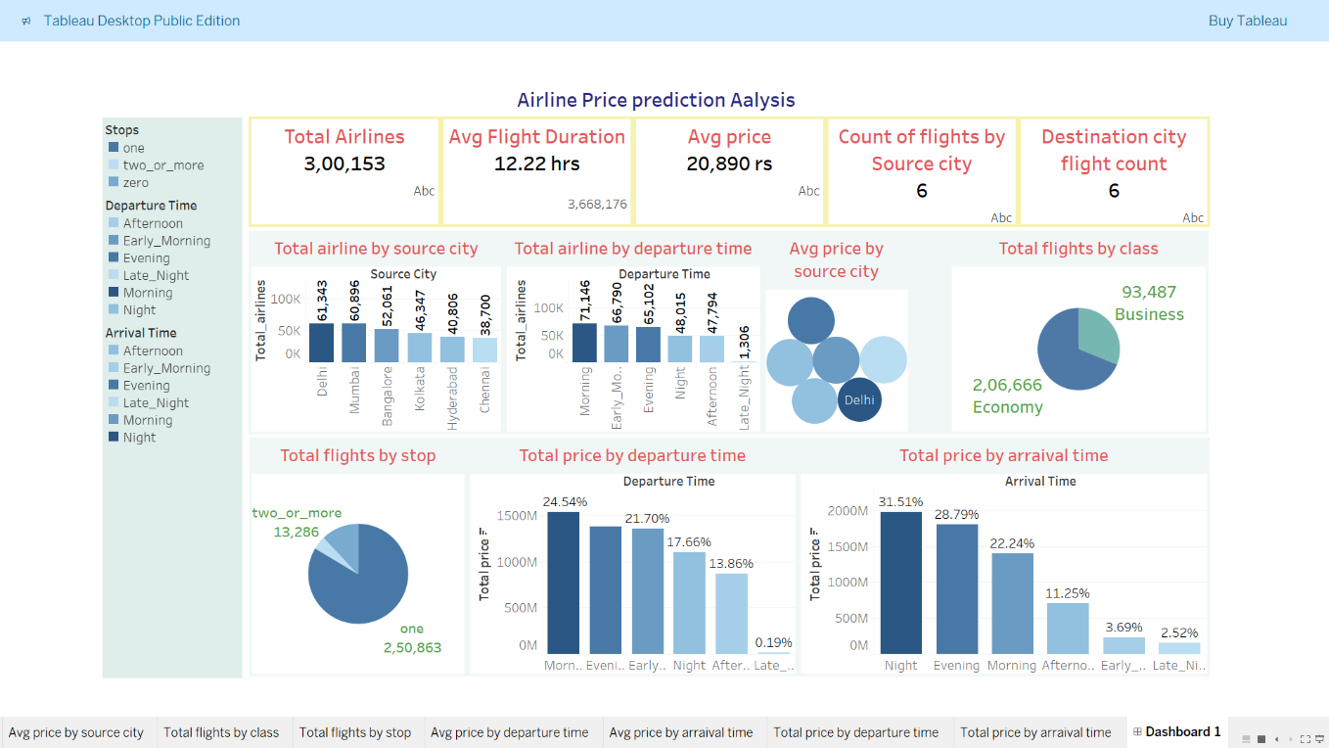

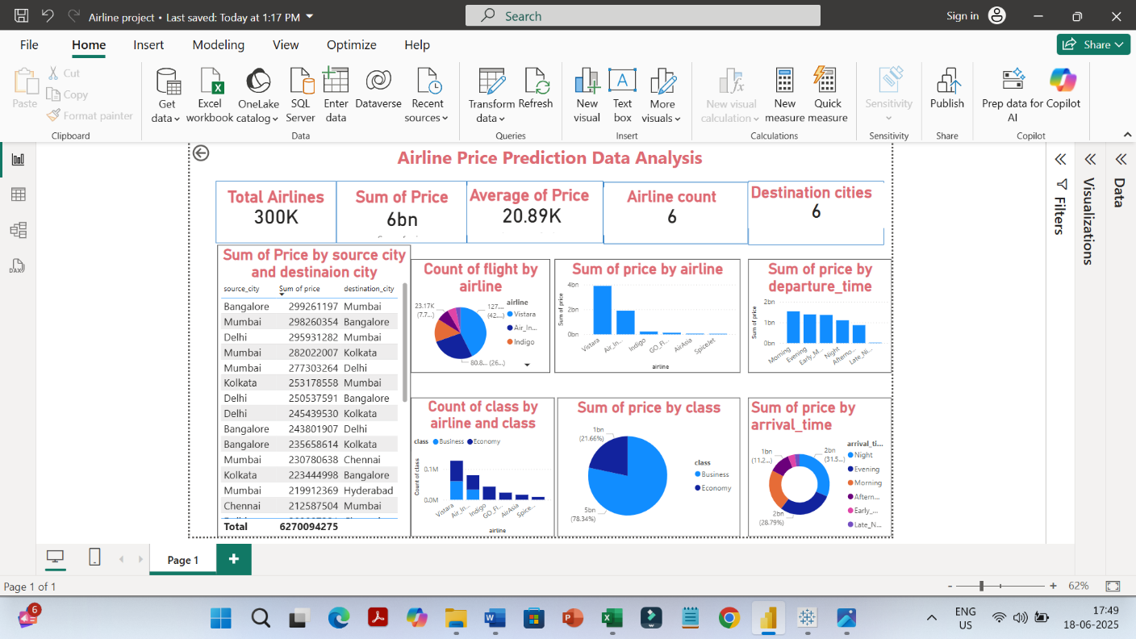

Insights & Conclusion

Insights

* Total airlines count is 300K and count of airlines by flight are 6
* Sum of price for all airlines is 6 bn and average price is 20.89K
* Count of destination cities and arrival cities are 6
* There are 6 timings for departure and arrival

Conclusion

* When we compare the sum of price, Vistara has more price compare with all other airlines and it has more flights serving business and economy with more of economy seat and Air India also has business and economy classes but rest are having only economy option for booking tickets
* When comparing the sum of price for timings Morning has more price for departure and night has more for arrival.
* When we compare sum of price for source city and destination city Bangalore has more as a source city and Mumbai has more as a destination city.
* Chennai and Hyderabad has less sum of price.
* There are more flights for economy and compare with prices economy has much less price compare to business class.
* There are more flights with one stop

In conclusion, Vistara has more flights with economy and business classes having more economy seats.

If an individual want to book flight for cheaper prices possibly late night is the best option.